Karachi AQI Prediction Dashboard

Abstract
This project presents an end-to-end automated Air Quality Index (AQI) prediction system that forecasts AQI levels for the next 72 hours of Karachi. The system integrates real-time data ingestion of weather and air pollutant data collected from Open Mateo API, followed by feature engineering and storage in a feature store using MongoDB Atlas.
Multiple models were trained and evaluated but Random Forest regression model was selected as the final model due to its superior performance, achieving an R² score of approximately 0.9. Shap Analysis found, that last hour aqi was the most important feature which helped model learn patterns. Model artifacts and versions were managed through a model registry using Dagshub (MLflow backend). The entire pipeline is automated using CI/CD workflows implemented with GitHub Actions, where the feature pipeline runs hourly and the model training pipeline runs daily, ensuring the model continuously learns from the latest data patterns.
A Streamlit-based interactive dashboard is developed to visualize and showcase AQI predictions. A Direct multi-output forecasting approach was employed instead of a recursive approach, as recursive forecasting suffers from error accumulation (snowball effect), which significantly degrades prediction accuracy over longer horizons.

Data Collection
Data for this project was collected from Open Meteo API that provides real-time weather and pollutants data. The data for the last 2 months was fetched as we needed huge amount of data so that model can learn patterns and give accurate predictions. Key data were AQI (Target variable), Date-time, PM2.5_ugm3 and some other data.
Feature Engineering and EDA
High model accuracy and reliable predictions largely depend on the quality and relevance of input features. Well-designed features allow the model to capture meaningful patterns, leading to improved performance and generalization. The relevance of features in this project was identified through Exploratory Data Analysis (EDA), which helped analyze relationships between variables and select features that most strongly influence AQI predictions. Like, last hour aqi was very important because aqi doesn’t change instantly. There is high percent chance that next hour aqi will be previous hour aqi unless there is incident like fire burst which can change aqi instantly. So according to results of EDA and nature of project I chose following features:
- Hour
- Day of week
- Aqi last hour
- Aqi last day
- Aqi change rate
- Wind speed
- Aqi

EDA Results
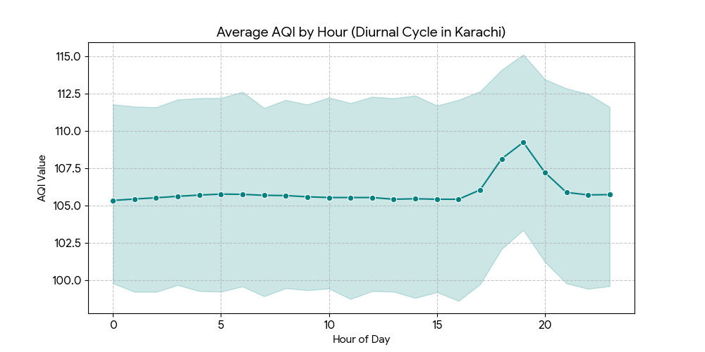
AQI values typically rise in the late morning and peak in the evening. This confirms that hour is a significant predictor because it captures the daily cycle of traffic congestion and industrial activity.

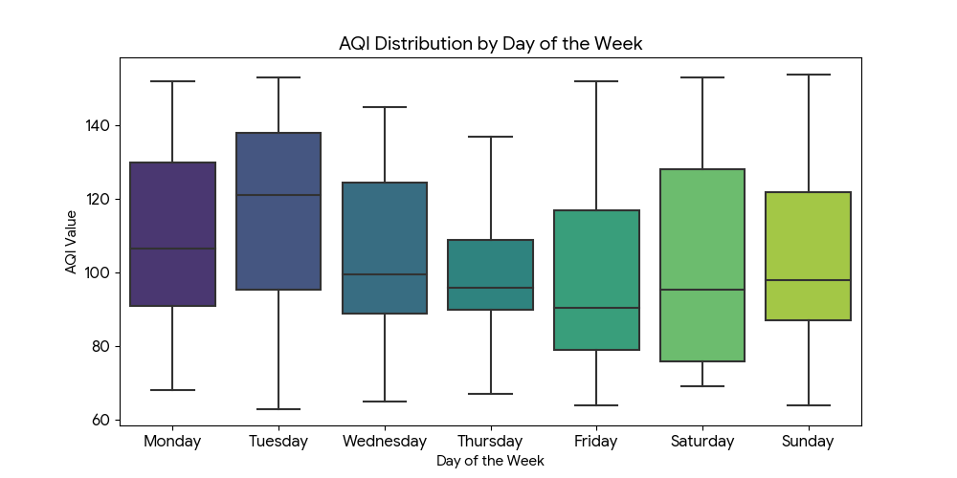
You can see shifts in the median AQI and the "spread" of pollution on different days. This proves that the model needs to know the day of the week to account for varying human activity levels in Karachi
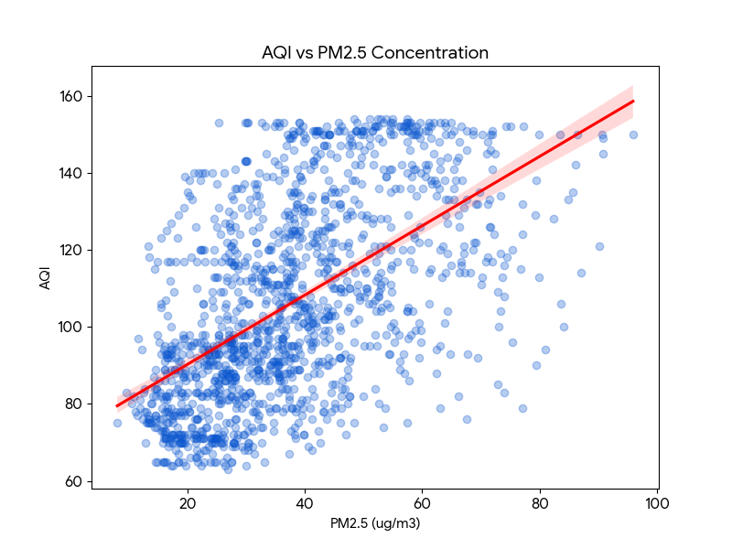
The AQI vs PM2.5 scatter plot shows a very tight, linear relationship.
As PM 2.5 increases, the AQI increases almost perfectly in tandem. This is the strongest evidence that PM 2.5 is a critical feature, as it is usually the primary pollutant determining the AQI score.
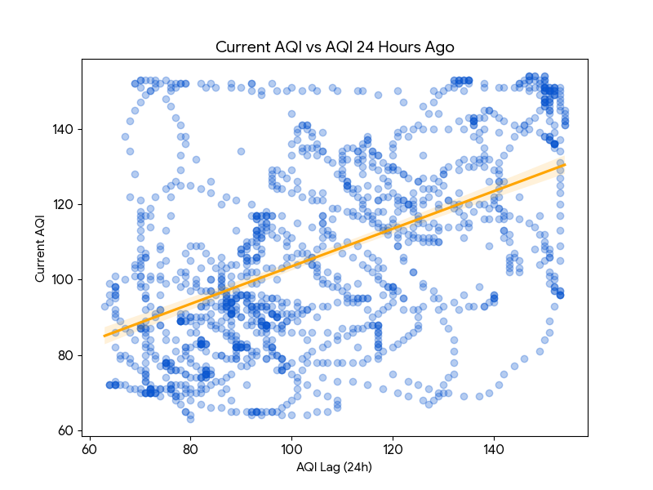
The Current AQI vs AQI 24 Hours Ago plot shows a strong positive correlation.
If the air was polluted yesterday at this time, it is highly likely to be polluted today. This justifies your use of lag features, as they capture the "momentum" of air quality.
Feature Store (MongoDB Atlas)
MongoDB Atlas was used as a centralized feature store to store all engineered features before model training and prediction. After feature engineering, the processed features were saved in MongoDB, ensuring a consistent and reusable feature set across training, evaluation, and inference pipelines. This approach decoupled feature generation from model training, allowing the system to always train on the latest engineered features while avoiding feature mismatch and data leakage. Using MongoDB as a feature store also enabled efficient retrieval of recent features for real-time prediction and supported continuous model updates in the automated CI/CD pipeline.
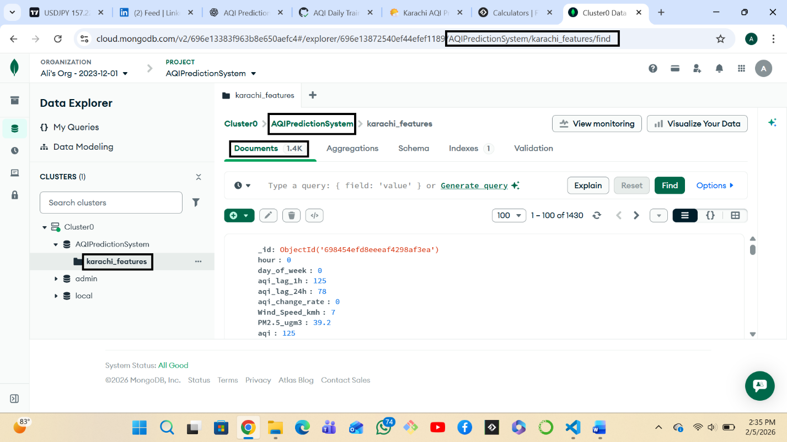

Model Development, Training and Evaluation
The training pipeline retrieves the latest feature data from MongoDB, performs a train-test split, and applies feature scaling using StandardScaler. Models are trained to predict 72 future AQI values simultaneously using a multi-output regression approach.

Multiple machine learning models were chosen for AQI prediction like Ridge Regression, Random Forest, Gradient Boosting and Neural Network (MLP). Random Forest was selected due to high performance on every metric like:
 | R2 Square | MAE | RMSE
Ridge Regression | 0.3618 | 15.25 | 19.9
Random Forest | 0.8672 | 5.79 | 9.07
Gradient Boosting | 0.7177 | 9.71 | 13.24
Neural Network (MLP) | 0.6516 | 11.03 | 14.7

Shap Analysis
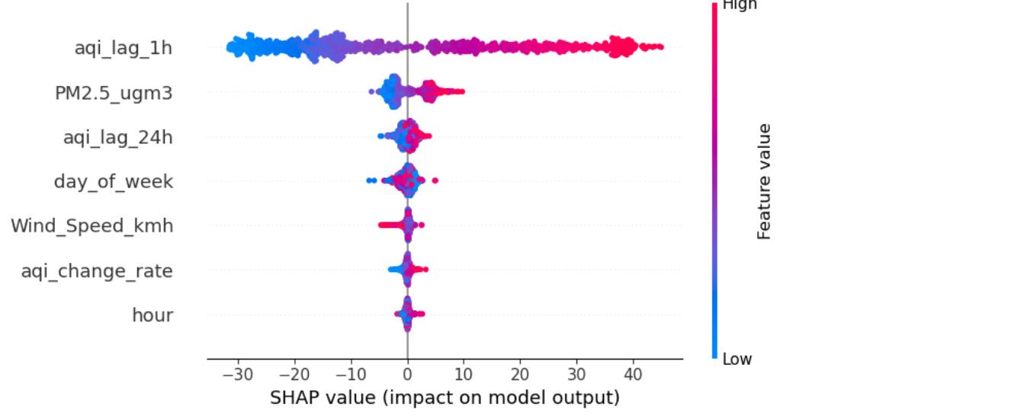
Picture clearly shows that AQI last hour had the most impact on model output. As said earlier, AQI can’t change instantly. Next hour AQI would most likely be previous hour AQI unless any incident happens like fire bust etc.

Model Registry and Versioning
Final model was send to Model Registry, which in our case is Dagshub. Model Versioning was handled using MLflow integrated with Dagshub. Each training run logs model artifacts, evaluation metrics and parameters. The model registry ensures that only the latest validated model is used for prediction while preserving historical versions for comparison and rollback. This approach enhances reproducibility and enables systematic experimentation.
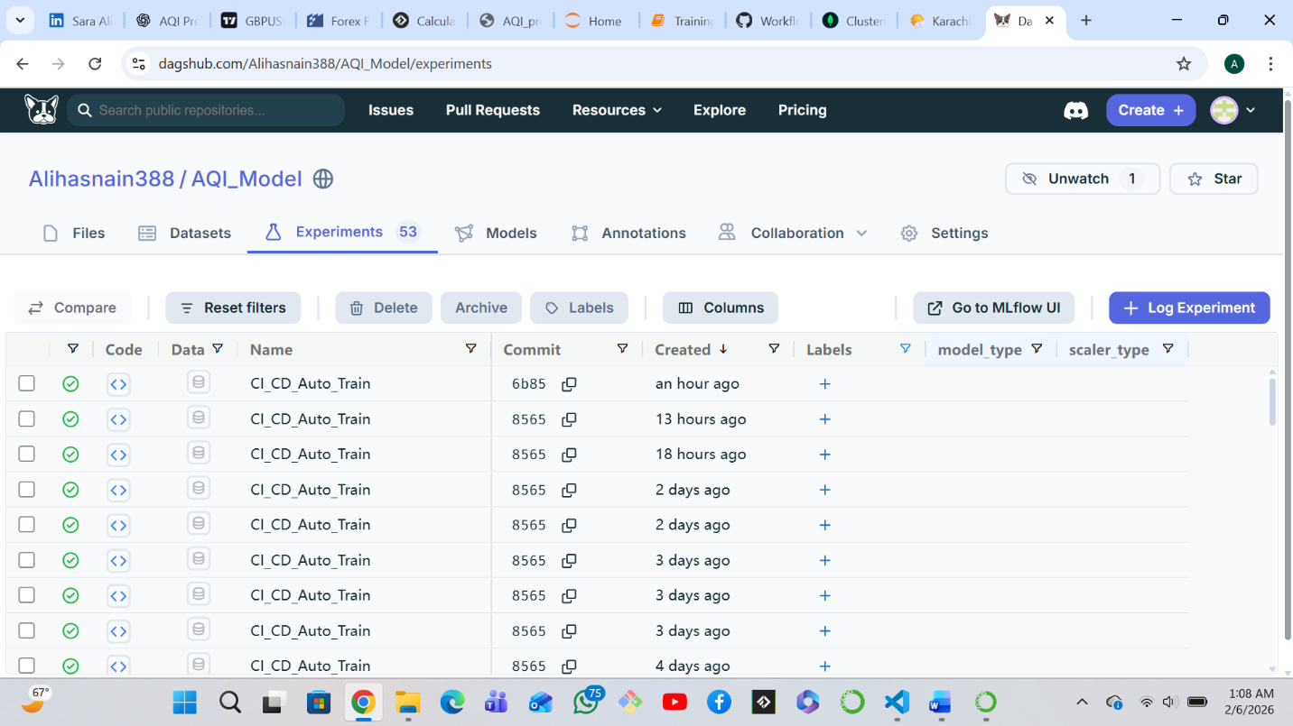
CI/CD Automation
To ensure continuous updates and eliminate manual intervention, the entire system is automated using GitHub Actions. The feature pipeline runs on an hourly schedule, extracting new data, generating features, and storing them in MongoDB. The training pipeline runs daily, retraining the model using the latest available data and registering the updated model in the Dagshub model registry.
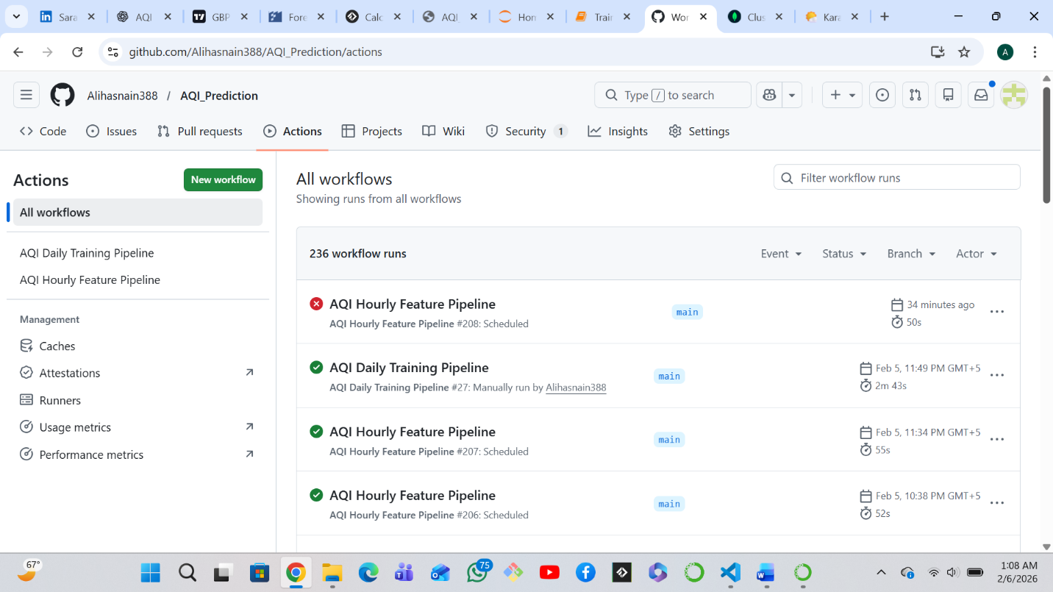

Prediction Pipeline and Dashboard
The prediction pipeline retrieves the latest registered model from Dagshub and the most recent features from MongoDB. Using these inputs, the system generates AQI predictions for the next 72 hours visualized using a Streamlit dashboard, which presents current AQI, 3-day Avg forecast and hourly forecast graph in an intuitive and user-friendly manner.
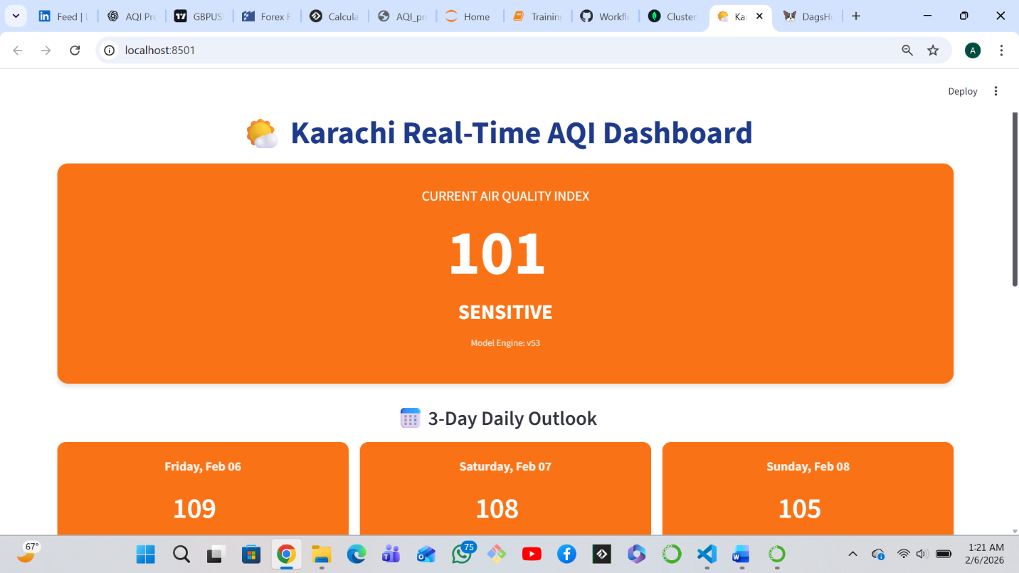
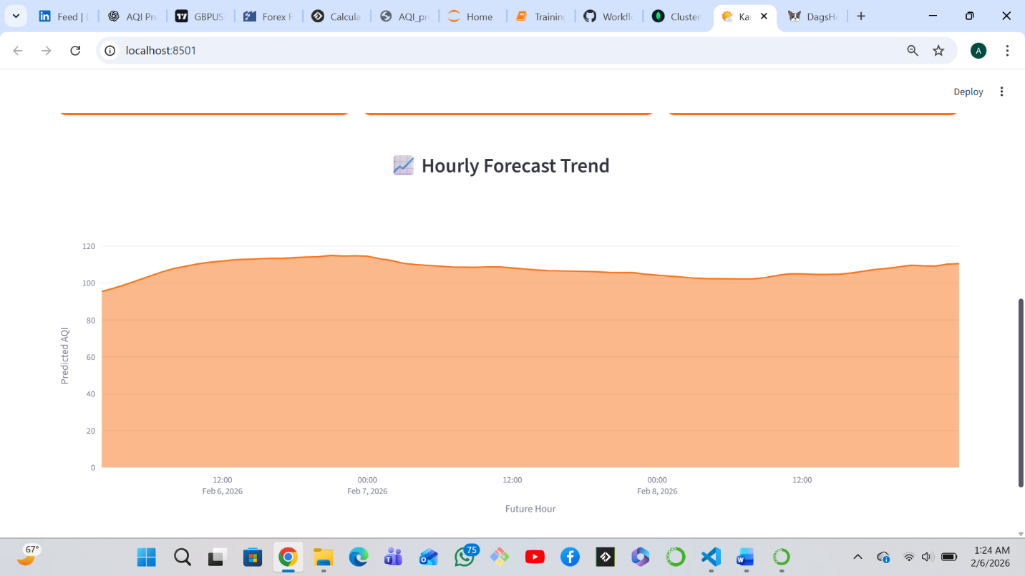

END

Challenges
- First, I chose Hopsworks as the feature store, but the features stored in Hopsworks were not being pulled into the Jupyter Notebook, which posed a challenge. I researched the issue and used ChatGPT for guidance, but the problem persisted. Eventually, I switched to MongoDB, and it worked successfully.
- The CI/CD pipeline was new to me, and it was a great learning experience. I faced two main problems. The first was related to the cron job YAML file, as it was new to me, so I took help from ChatGPT and conducted additional research. The second challenge was the waiting issue. The manual workflow was working, but the automatic workflow was not. This made me question what the issue could be. I waited for 2 to 3 hours, and eventually, it worked. I realized that the first automatic workflow can take longer to execute, while subsequent runs proceed at a normal pace.
- Model Registry was new to me as well. Since Hopsworks was not working, I researched alternatives and came across Dagshub. I explored its UI, features, and how to deploy models inside it. This also posed a challenge.

